Web Development in 2024
These are the best backend development frameworks for web development in Java, Ruby, Python, JavaScript, PHP, Scala, and Golang in 2024
For the web application Programming Developers the best backend frameworks to learn in 2024.
Full Stack Development includes both front end and back end
10 best backend frameworks for creating web applications.
Web development is generally divided into two categories — Frontend development and backend development. A Backend developer is responsible for building the server-side of a web application.
As the frontend part interacts with the user, the backend part is responsible for the inner working. A frontend may or may not work without a backend but to create a fully functional web application, it is necessary to have a proper backend connected with a frontend.
The role of a backend developer is different from a frontend developer. A frontend developer is more focused on how the application will appear while a backend developer is focused on servers, databases, and how both ends are connected and interacting with each other.
A Backend developer should have many necessary skills. Understanding backend frameworks is one of them. There are several backend frameworks and this article will discuss the top backend frameworks which are used today.
The list includes the best backend framework based upon programming language and tech stack. This means you don’t need to learn all of them, instead choose the one which matches your choice of programming language and tech stack.
10 Best Backend Framework for Web Development in 2024
Without wasting any more of your time, here is a list of the 10 best Backend frameworks programmers can learn for web development. While there are many choices in a particular tech stack or programming language like for Java developers, there are MicroNaut, Quarkus, Vert.X, and other frameworks but I have only chosen the best frameworks like Spring Boot based upon popularity, maturity, and functionalities.
1. Spring Framework + Spring boot for Java Developers
Java is regarded as an evergreen programming language. One of its popular use is in backend development. Spring Framework is one of the best Java frameworks.
It was released in 2002 and today, it is one of the most popular backend frameworks that is used to create production-grade spring-based and standalone applications.
It is easy to use Spring boot because it omits various configuration overheads which Spring Framework has. You can get a lot of useful functionalities like caching, transaction management, configuration management, monitoring, security etch when you use Spring Framework projects like Spring Boot, Spring Cloud Spring Security, etc.
If you want to learn Spring Framework and Spring Boot in 2024 and need a resource, then I highly recommend you to join the Spring and Hibernate (includes Spring Boot) course on Udemy. More than 200,000 Java developers have joined this course to learn Spring, Hibernate, and Spring Boot, three of the most essential backend frameworks in Java.

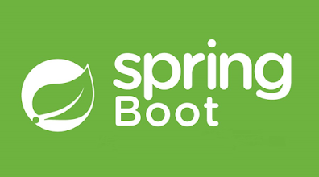

2. Django for Python Developers
Django is the most popular Python framework used in web development. Based on the Don’t Repeat Yourself (DRY) principle, Django focuses on code reusing, thus enhancing the development speed. It is also a very secure framework.
Being a Python framework, Django is very user-friendly and easy to learn. It’s also one of the most popular full-stack frameworks and provides a lot of functionality out-of-box like REST API support.
If you want to learn Django in 2024 then I suggest you join Python and Django Full Stack Web Developer Bootcamp course by Jose Portilla on Udemy.
Jose is a great instructor and this 32-hour long Django course is one of the most comprehensive resources to learn Django online.

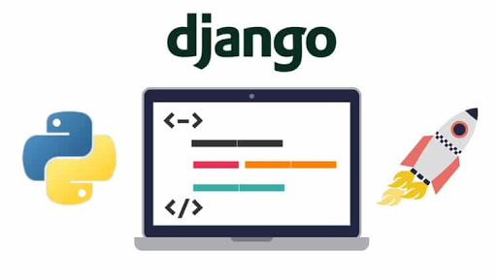

3. Express.js for JavaScript Developers
JavaScript is the most popular programming language in the world. With the emergence of Node.js, JavaScript’s popularity in the backend development community increased rapidly and in the last decade, Node.js has become one of the top names.
This is why Express was released in 2010 for node developers. It is a minimal Node.js framework used to develop highly flexible applications.
Given that JavaScript is the most popular web development language and probably the only language which provides full-stack development from front to the backend to mobile learning Express.js can be a great choice for programmers.
If you want to learn Express.js in 2024 and need a resource, I recommend MERN Stack Front To Back: Full Stack React, Redux & Node.js course by my favorite Udemy instructor Brad Traversy, this course is great for anyone who wants to learn full-stack web development using MERN stack, which includes both React and Express.js.

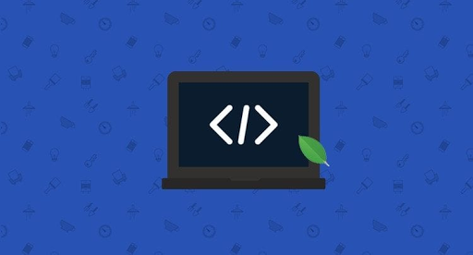

4. ASP.NET core for .NET developers
ASP.NET core is the successor of ASP.NET. It is an open-source, platform-independent framework used to build web applications on the .NET platform. It is regarded as one of the best-performing backend frameworks.
It is basically a united version of ASP.NET MVC and ASP.NET Web API into a programming module, thus making it more powerful.

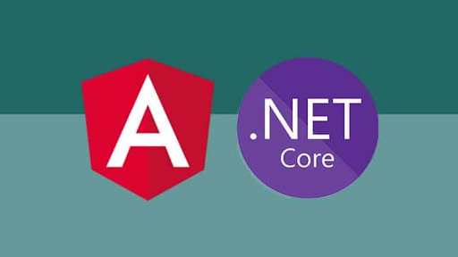

5. Laravel for PHP Programmers
PHP is one of the most used programming languages in backend development. Laravel is a PHP framework that is based on MVC architecture. It is a beginner-friendly framework that has a user-friendly interface, extensive library, and brilliant API support.
Using Laravel simplifies the backend development while building modern secure web applications. This is especially true if you are working on non-trivial applications.
If you want to learn Larval and looking for the best online course to learn Laravel for PHP developers then you can also check out PHP with Laravel for beginners — Become a Master in Laravel course on Udemy. This 43 hours long course is one o the best course to learn Laravel online.

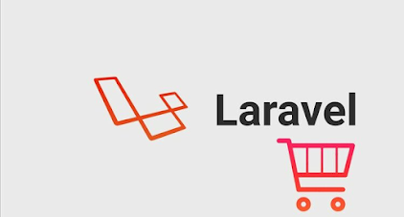

6. Ruby on Rails for Ruby Programmers
Ruby on rails, commonly knowns as Rails is a server-side framework based on MVC architecture. It is a beginner-friendly framework that is easy to understand and learn.
However, its advantages and disadvantages are still debated, but it is loved by backend developers throughout the world for being user-friendly.
If you want to learn Ruby on Rails in 2024 and need a resource The Complete Ruby on Rails Developer Course by Rob Percival on Udemy is a great course to join. It has more than 46 hours of content and 157 articles, 8 coding exercises, and 1 downloadable resource.

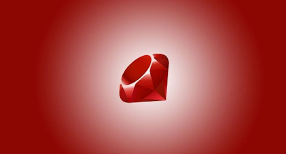

7. Fiber Framework for Golang Developers
Fiber is a web development framework for Golang programmers. It is built on top of Fasthttp, the fastest HTTP engine for Go. It’s designed to ease things up for fast development with zero memory allocation and performance in mind
Fiber is a lean but extremely powerful framework. Being extremely lean, it is easy to integrate third-party libraries with Martini. The framework offers more scalability and fewer overhead problems.
It’s similar to Express.js and has great support for routing, serving static files, building REST APIs, Flexible Middleware support, Template engine, and low memory footprint.
If you want to learn more about building web applications using Golang and Fiber, I suggest you join The Complete React & Golang Course by Rob Percival and CodeStars on Udemy. It’s a project-based course where you will build an admin app from scratch using React and Golang Fiber.

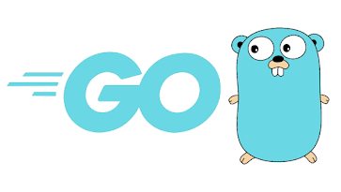

8. CakePHP Framework for PHP Developers
CakePHP is another PHP framework that is based on the concepts of another popular backend framework, Ruby on rails.
It follows MVC architecture and offers several useful features such as model-view-controller, front controller, active record, data mapping, and convention over configuration.
If you want to learn CakePHP from scratch and need a resource, I suggest you check out CakePHP for Beginner to Advance with Complete Project course on Udemy. This 6-hour long course is the highest-rated CakePHP course on Udemy and is suitable for beginners and experienced PHP programmers.

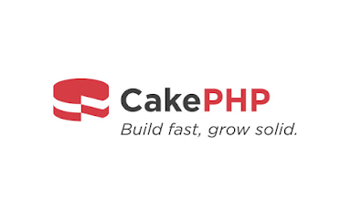

9. Flask Framework for Python Developers
Flask is another python framework that you can use for backend development. It is regarded as a microframework because it omits the use of specific tools and libraries. Moreover, there is no database abstraction layer, form validation, or external source dependency.
It’s a simple, highly flexible, and performing web framework. Being a lightweight framework, or micro-framework, it is easy to learn and understand Flask. Moreover, being a Python framework, it is very user-friendly.
If you want to learn Flask from scratch and need a resource then you can also check out REST APIs with Flask and Python course on Udemy. Created by Jose Salvatierra, this 17-hour long course is great to learn Flask for web development.

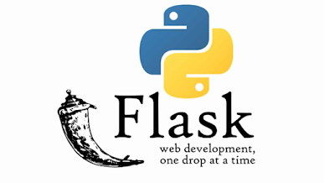

10. Play Framework for Scala Developers
Written in Scala and Java, PLAY is one of the most powerful backends web frameworks. It is based on MVC architecture and offers various features such as hot code reloading, displaying program blunders, and focusing on upgrading developer profitability.
Moreover, it is RESTfull and non-blocking.
If you want to learn Scala and start using Play Framework for web development and need a resource to start learning online then I recommend you join Scala & Functional Programming for Beginners | Rock the JVM course on Udemy.
It’s a great course to learn Scala online, required for the Play framework and more than 30K students have already joined this course.

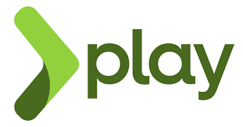

That’s all about the best backend frameworks programmers can learn in 2024. As I said, if you want to become a full-stack engineer or backend engineer, it is worth learning backend development. Today, backend development is dependent on the backend frameworks.
There are several backend frameworks, some popular and some not. In this article, we discussed the top tend backend frameworks. All these frameworks are very popular in the backend community and there is a huge demand for them in the job market.
Most of these frameworks are written in popular programming languages such as
- Java, Spring Boot,
- Python, Django and Flask
- JavaScript, MERN STACK
If you are a beginner, you can start with beginner-friendly frameworks such as Ruby on rails or lightweight frameworks such as Flask. And if you are keen on learning the most popular ones, then you can go for Spring Boot, Django, or Express.

